# A

**PROJECT REPORT ON**

**“Automatic Attendance System”**

### Submitted as partial fulfilment of requirement for the award to degree of B.Sc.(H) Comp. Science

By Satyabrata Sahoo

Roll No: -

University Regd. No: -

B.Sc. Comp. Sc. 3rd Year (6th Semester) Under The Guidance

Of

Mr. Sandeep Panigrahi Lecture in Computer Science

DEPARTMENT OF COMPUTER SCIENCE UNIQUE INSTITUTE OF INFORMATION TECHNOLOGY

NAYAGARH, 752069

### (AFFILIATED TO UTKAL UNIVERSITY, BHUBANESWAR, ODISHA) SESSION 2017-2020

j

**ACKNOWLEDGMENT**

I would like to express my deepest gratitude and thanks to my supervisor, Mr. Sandeep Panigrahi, who suggested the idea of Automatic Attendance System who gave me the needed information to start working on the project. Also, I would like to thank him for being supportive and for his guidance through this semester and for giving me the necessary advices to be able to realize this project. I am really grateful to his contribution. Moreover, I would like to thank him for his supervising methodology that made by tasks easier and motivated me through this period.

CERTIFICATE

Finally, I would like to thank my parents, sister and all my friends for their support. They have supported me during the difficult moments and encouraged me in carrying out this project work.

Signature: Roll No:

**DECLARATION**

I declare that this project entitled “Automatic Attendance System” done at Unique Institute of Information Technology, Nayagarh College is a record of project work submitted by me for the partial fulfilment of the semester exam of CBSE under the supervision and guidance of Mr Sandeep Panigrahi.

The Project is genuine and not a reproduction of any project previously done or submitted.

Signature: Roll No:

**UNIQUE INSTITUTE OF INFORMATION TECHNOLOGY, NAYAGARH, 752069**

DEBOTTAR COLONY, Ph. No: 06753-253081

**DEPARTMENT OF COMPUTER SCIENCE**

**CERTIFICATE**

Certified that the Project work entitled “Optical Character Recognition” is a bona fide work carried out by Satyabrata Sahoo (66502NT17019), in partial fulfilment of the requirements for the award of the Degree of Bachelor in Computer Science of UTKAL University, BHUBANESWAR, during the year 2017- 2020. It is certified that all the corrections/suggestions indicated for internal assessment have been incorporated in the report. The Seminar report has been approved as it satisfies the academic requirements in respect of Project work prescribed for the B.Sc.(H) Computer Science.

Signature of Principal Signature of Guide

College Seal

**ABSTRACT**

Uniqueness or individuality of an individual is his face. In this project face of an individual is used for the purpose of attendance making automatically. Attendance of the student is very important for every college, universities and school. Conventional methodology for taking attendance is by calling the name or roll number of the student and the attendance is recorded. Time consumption for this purpose is an important point of concern. Assume that the duration for one subject is around 60 minutes or 1 hour & to record attendance takes 5 to 10 minutes. For every tutor this is consumption of time. To stay away from these losses, an automatic process is used in this project which is based on image processing. In this project face detection and face recognition is used. Face detection is used to locate the position of face region and face recognition is used for marking the understudy’s attendance. The database of all the students in the class is stored and when the face of the individual student matches with one of the faces stored in the database then the attendance is recorded.

**CONTENT**

|  |  |  |
| --- | --- | --- |
| **Chapter - 1** | **Finding the Problem-Introduction** | **01** |
| **Chapter - 2** | **Literature Review** | **05** |
| **Chapter - 3** | **Digital Image Processing (DIP)** | **09** |
| **Chapter - 4** | **Face Detection and Recognition** | **12** |
| **Chapter - 5** | **Requirement Specification** | **14** |
| **Chapter - 6** | **Application Design** | **15** |
| **Chapter - 7** | **Software Component and Technology Used** | **17** |
| **Chapter - 8** | **Analysis and Testing** | **18** |
| **Chapter - 9** | **Implementation Result** | **22** |
| **Chapter - 10** | **Finding and Conclusions** | **31** |

**CHAPTER – 1**

**FINDING THE PROBLEM - INTRODUCTION**

Face recognition is the task of identifying an already detected object as a known or unknown face often the problem of face recognition is confused with the problem of face detection Face Recognition on the other hand is to decide if the "face" is someone known, or unknown, using for this purpose a database of faces in order to validate this input face.

* 1. **FACE RECOGNIZATION:**

DIFFERENT APPROACHES OF FACE RECOGNITION:

There are two predominant approaches to the face recognition problem: Geometric (feature based) and photometric (view based). As researcher interest in face recognition continued, many different algorithms were developed, three of which have been well studied in face recognition literature.

Recognition algorithms can be divided into two main approaches:

* + 1. **Geometric:** Is based on geometrical relationship between facial landmarks, or in other words the spatial configuration of facial features. That means that the main geometrical features of the face such as the eyes, nose and mouth are first located and then faces are classified on the basis of various geometrical distances and angles between features.
    2. **Photometric stereo:** Used to recover the shape of an object from a number of images taken under different lighting conditions. The shape of the recovered object is defined by a gradient map, which is made up of an array of surface normal (Zhao and Chellappa, 2006).

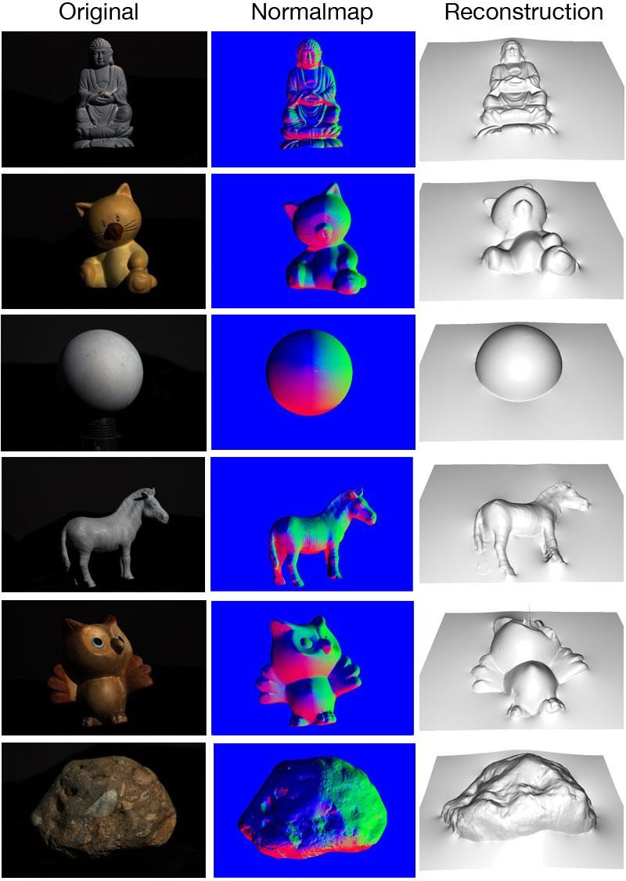

[ PHOTOMETRIC STERIO IMAGE]

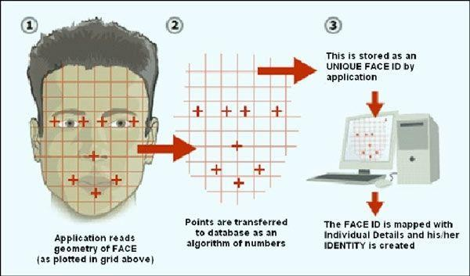

[ GEOMETRIC FACIAL RECGNITION]

##### FACE DETECTION:

Face detection involves separating image windows into two classes; one containing faces (turning the background (clutter). It is difficult because although commonalities exist between faces, they can vary considerably in terms of age, skin color and facial expression. The problem is further complicated by differing lighting conditions, image qualities and geometries, as well as the possibility of partial occlusion and disguise. An ideal face detector would therefore be able to detect the presence of any face under any set of lighting conditions, upon any background. The face detection task can be broken down into two steps. The first step is a classification task that takes some arbitrary image as input and outputs a binary value of yes or no, indicating whether there are any faces present in the image. The second step is the face localization task that aims to take an image as input and output the location of any face or faces within that image as some bounding box with (x, y, width, height).

The face detection system can be divided into the following steps: -

**Pre-Processing:** To reduce the variability in the faces, the images are processed before they are fed into the network. All positive examples that is the face images are obtained by cropping images with frontal faces to include only the front view. All the cropped images are then corrected for lighting through standard algorithms.

**Classification:** Neural networks are implemented to classify the images as faces or non faces by training on these examples. We use both our implementation of the neural network and the Matlab neural network toolbox for this task. Different network configurations are experimented with to optimize the results.

**Localization:** The trained neural network is then used to search for faces in an image and if present localize them in a bounding box. Various Feature of Face on which the work has done on: Position Scale Orientation Illumination.

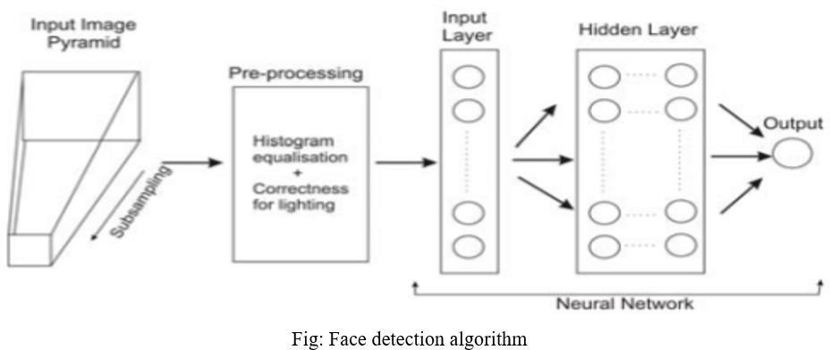

**CHAPTER –2** **LITERATURE REVIEW**

Face detection is a computer technology that determines the location and size of human face in arbitrary (digital) image. The facial features are detected and any other objects like trees, buildings and bodies etc. are ignored from the digital image. It can be regarded as a specific case of object-class detection, where the task is finding the location and sizes of all objects in an image that belong to a given class. Face detection, can be regarded as a more general case of face localization. In face localization, the task is to find the locations and sizes of a known number of faces (usually one). Basically, there are two types of approaches to detect facial part in the given image i.e. feature base and image base approach. Feature base approach tries to extract features of the image and match it against the knowledge of the face features. While image base approach tries to get best match between training and testing images.

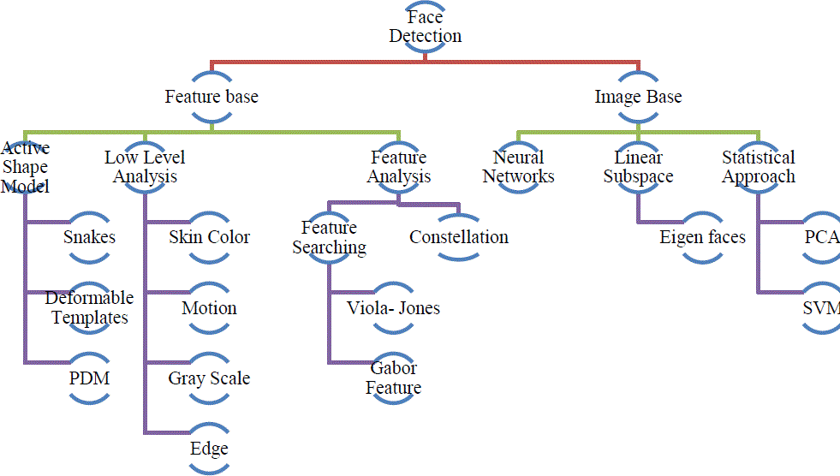

##### FEATURE BASE APPROACH:

Active Shape Model Active shape models focus on complex non-rigid features like actual physical and higher-level appearance of features Means that Active Shape Models (ASMs) are aimed at automatically locating landmark points that define the shape of any statistically modelled object in an image. When of facial features such as the eyes, lips, nose, mouth and eyebrows. The training stage of an ASM involves the building of a statistical

* + 1. facial model from a training set containing images with manually annotated landmarks.

ASMs is classified into three groups i.e. snakes, PDM, Deformable templates

1.1) Snakes: The first type uses a generic active contour called snakes, first introduced by Kass et al. in 1987 Snakes are used to identify head boundaries [8,9,10,11,12]. In order to achieve the task, a snake is first initialized at the proximity around a head boundary. It then locks onto nearby edges and subsequently assume the shape of the head. The evolution of a snake is achieved by minimizing an energy function, snake (analogy with physical systems), denoted as snake = internal + External Where internal and External are internal and external energy functions. Internal energy is the part that depends on the intrinsic properties of the snake and defines its natural evolution. The typical natural evolution in snakes is shrinking or expanding. The external energy counteracts the internal energy and enables the contours to deviate from the natural evolution and eventually assume the shape of nearby features—the head boundary at a state of equilibria. Two main consideration for forming snakes i.e. selection of energy terms and energy minimization. Elastic energy is used commonly as internal energy. Internal energy is vary with the distance between control points on the snake, through which we get contour an elastic-band characteristic that causes it to shrink or expand. On other side external energy relay on image features. Energy minimization process is done by optimization techniques such as the steepest gradient descent. Which needs highest computations. Huang and Chen and Lam and Yan both employ fast iteration methods by greedy algorithms. Snakes have

##### 2.2) IMAGE BASED APPROACH:

Based on low level visual features like color, intensity, edges, motion etc. Skin Color Base Color is a vital feature of human faces. Using skin-color as a feature for tracking a face has several advantages. Color processing is much faster than processing other facial features. Under certain lighting conditions, color is orientation invariant. This property makes motion estimation much easier because only a translation model is needed for motion estimation. Tracking human faces using color as a feature has several problems like the color representation of a face obtained by a camera is influenced by many factors (ambient light, object movement, etc.

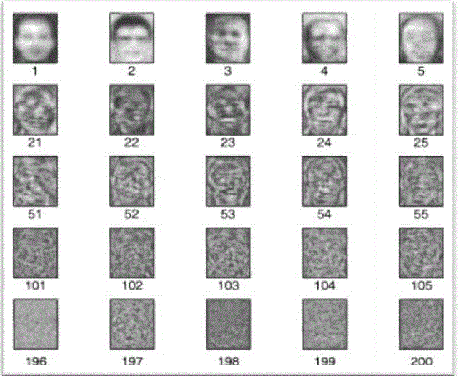

Majorly three different face detection algorithms are available based on RGB, YCbCr, and HIS color space models. In the implementation of the algorithms there are three main steps viz.

1. Classify the skin region in the color space,
2. Apply threshold to mask the skin region and
3. Draw bounding box to extract the face image.

Crowley and Coutaz suggested simplest skin color algorithms for detecting skin pixels. The perceived human colour varies as a function of the relative direction to the illumination.

The pixels for skin region can be detected using a normalized color histogram, and can be normalized for changes in intensity on dividing by luminance. Converted an [R, G, B] vector is converted into an [r, g] vector of normalized color which provides a fast means of skin detection. This algorithm fails when there are some more skin region like legs, arms, etc. Cahi and Ngan [27] suggested skin color classification algorithm with YCbCr color space. Research found that pixels belonging to skin region having similar Cb and Cr values. So that the thresholds be chosen as [Cr1, Cr2] and [Cb1, Cb2], a pixel is classified to have skin tone if the values [Cr, Cb] fall within the thresholds. The skin color distribution gives the face portion in the color image. This algorithm is also having the constraint that the image should be having only face as the skin region. Kjeldson and Kender defined a color predicate in HSV color space to separate skin regions from background. Skin color classification in HSI color space is the same as YCbCr color space but here the responsible values are hue (H) and saturation (S). Similar to above the threshold be chosen as [H1, S1] and [H2, S2], and a pixel is classified to have skin tone if the values [H,S] fall within the threshold and this distribution gives the localized face image. Similar to above two algorithm this algorithm is also having the same constraint.

# CHAPTER – 3

**DIGITAL IMAGE PROCESSING**

##### DIGITAL IMAGE PROCESSING

Interest in digital image processing methods stems from two principal application areas:

* + 1. Improvement of pictorial information for human interpretation
    2. Processing of scene data for autonomous machine perception

In this second application area, interest focuses on procedures for extracting image information in a form suitable for computer processing.

Examples includes automatic character recognition, industrial machine vision for product assembly and inspection, military recognizance, automatic processing of fingerprints etc.

Image:

Am image refers a 2D light intensity function f(x, y), where(x, y)

denotes spatial coordinates and the value of f at any point (x, y) is proportional to the brightness or gray levels of the image at that point. A digital image is an image f (x, y) that has been discretized both in spatial coordinates and brightness. The elements of such a digital array are called image elements or pixels.

A simple image model:

To be suitable for computer processing, an image f(x, y) must be digitalized both spatially and in amplitude. Digitization of the spatial coordinates (x, y) is called image sampling. Amplitude digitization is called gray-level quantization.

The storage and processing requirements increase rapidly with the spatial resolution and the number of gray levels.

Example: A 256 gray-level image of size 256x256 occupies 64k bytes of memory.

Types of image processing

* + - * Low level processing
      * Medium level processing
      * High level processing

[9]

Low level processing means performing basic operations on images such as reading an image resize, resize, image rotate, RGB to gray level conversion, histogram equalization etc.…, The output image obtained after low level processing is raw image. Medium level processing means extracting regions of interest from output of low-level processed image. Medium level processing deals with identification of boundaries i.e. edges. This process is called segmentation. High level processing deals with adding of artificial intelligence to medium level processed signal.

##### FUNDAMENTAL STEPS IN IMAGE PROCESSING Fundamental Steps in image processing are

* + 1. Image acquisition to acquire a digital image
    2. Image pre-processing: to improve the image
    3. Image Segmentation: to partitions an input image into its constituent parts of object
    4. Image Knowledge base to convert the input data to a form for suitable computer processing.
    5. Image description: to extract the features that result in some quantitative information of interest of features that are basic for differentiating one class of objects from another.

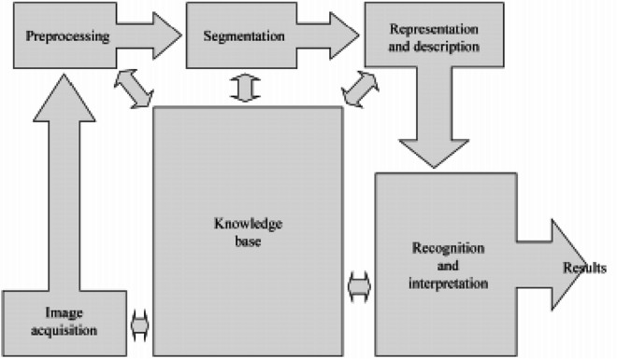

* 1. **ELEMENTS OF DIGITAL IMAGE PROCESSING SYSTEMS**

A digital image processing system contains the following blocks as shown in the figure

Processing Unit

* Computer
* Work station

Display unit

* TV monitors
* Printers
* Projectors

Image acquisition equipments

* Video
* Scanner

Storage

* Optical discs
* Tape
* Video tape
* Magnetic discs

Communication Channel

The basic operations performed in a digital image processing system include

1. Acquisition
2. Storage
3. Processing
4. Communication
5. Display

**CHAPTER – 4**

**FACE DETECTION AND RECOGNITION**

##### FACE DETECTION:

Face detection is defined as finding the position of the face of an individual. In other word it can be defined as locating the face region in an image. After detecting the face of human its facial features is extracted and has wide range of application like facial expression recognition, face recognition, observation systems, human PC interface and so forth…Detecting face in an image of single person is easy but when we consider a group image of an image containing multiple faces, the task becomes difficult. For the application of face recognition, detection of face is very important and the first step. After detecting face, the face recognition algorithm can only be functional. Face detection itself involves some complexities for example surroundings, postures, enlightenment etc. There are some existing methodologies for detection of face. Some of them are skin color based, characteristic or feature based (feature like mouth, nose and eyes) and neural network based. Among the above techniques, the skin-based procedure is well thought-out as simplest one. The approach premeditated and applied in this thesis is the skin color-based face detection method. The algorithm is pretty dynamic as numerous people face can be detected at one time from an image containing many people. In this project YCbCr color model is used to detect the skin of human being.

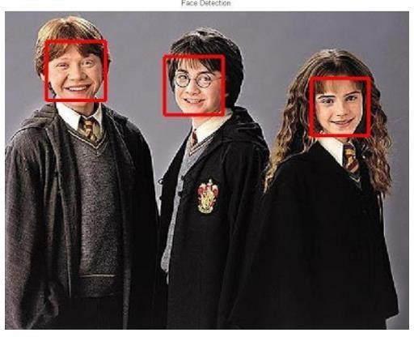

FACE DETECTION

* 1. **FACE RECOGNITION:**

The recognition of face of human is challenging in computer-human interaction. The face is our essential center of consideration in societal life playing a critical part in assigning identification and emotion of the person. We can perceive various appearances adapted all through our lifespan and distinguish faces initially even following quite a while of detachment. This expertise is very vigorous notwithstanding of substantial varieties in visual boost because of evolving condition, maturing and diversions, for example, facial hair, glasses or changes in haircut. Computational models of face acknowledgment are fascinating in light of the fact that they can contribute to hypothetical learning as well as to functional applications. PCs that identify and recognizes the face could be connected to a broad assortment of undertakings together with criminal recognizable proof, security framework, image and film handling, identity confirmation and human-PC interaction. Tragically, adding to a computational model of face recognition and acknowledgment is very troublesome in light of the fact that faces are perplexing, multidimensional and important visual stimuli. This project uses the principal component analysis (PCA) for face recognition. There are many other face recognition algorithms, but principal component analysis (PCA) based face recognition is the simplest one for face recognition.



**RON**

**HARY**

**HERMIONE**

FACE RECOGNITION

## CHAPTER – 5 REQUIREMENT SPECIFICATION

After feasibility study and a deep understanding of the functionalities of the project, and after looking at the tools that we will be needed to develop and realize the application, My teammates and I have been able to collect the main user classes and the different requirements and classify them as follows:

##### INTERFACE REQUIREMENTS:

User must have installed a physical web cam to recognize the faces as well as to create a data set of students. Before taking the attendance, the user must create a dataset of students by adding students and train the software with those data set. The recognizer will recognize the trained images and ignore all the new faces and mark the attendance for only recognized students.

##### The software will work as follows:

* + 1. Add student details such as Name and Roll Number (Stored Inside an excel file)
    2. Take Image of the Student (Takes 60 images per student)
    3. Train the software with the images taken earlier
    4. Take the attendance (Creates an excel sheet)

##### FUNCTIONAL REQUIREMENTS OF THE SYSTEM:

We have classified these functional requirements as follows:

* + 1. Add Student details/Take images
    2. Train Images
    3. Take the attendance

##### NON-FUNCTIONAL REQUIREMENTS OF THE SYSTEM:

The software shall be user friendly and does not require any guidance to be used. In other words, the software has to be simple as possible, so its user shall use it easily. Actually, the interface is quite simple and straight forward so that anyone can understand it. The user should enter the student information and click “Take Image” button to take the images of the student as well as add that student to the existing sheet. Likewise, by clicking the “Train Image” button the user can train the software and “Track Images” button to mark the attendance.

## CHAPTER – 6 APPLICATION DESIGN

The design of the application is highly important in order to fulfil the requirements and functionalities of the project.

##### ARCHITECTURE OF THE SYSTEM:

At this level, we were able to identify the most important modules that we designed as follows:

Add student details

##### The System is modelled as follows:

Face recognition

Face detection/Train the System

Take Image/Add Student

Mark Attendance

The interface of the system is separated from its logic by using a Model View Controller. The Model contains the data while the interface constructs the view of the architecture. The controller matches between the model and the view. All communications between the model and the view will go through the controller. Moreover, the interface does not follow the logic of the application which makes the architecture of the system easier.

* + - There are two text fields for inserting student name and id.
    - There is Notification tab to display the status of any operation.
    - There is an Attendance tab to see the attendance sheet.
    - The Take Images button is used to take student images as well as add that student to the database.
    - The train image button trains the system with the existing dataset.
    - The Track image button recognizes the images and marks the attendance.

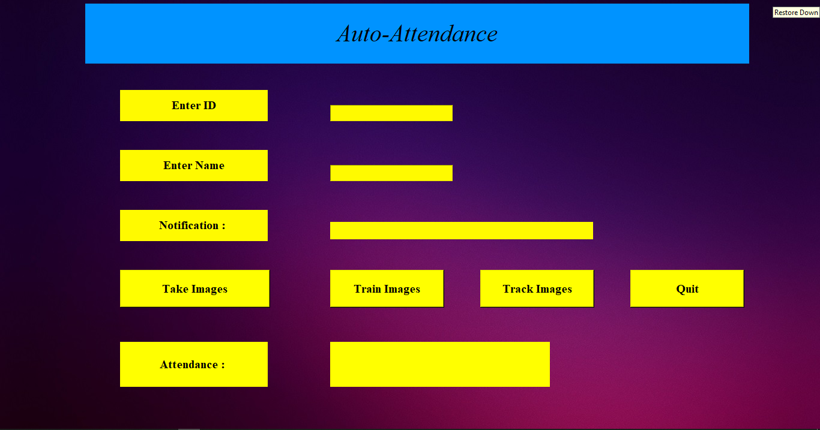

PROPOSED DESIGN

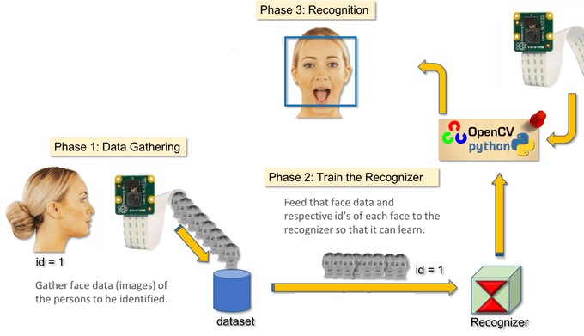

PROPOSED APPROACH

## C:\Users\Rutadeep\AppData\Local\Microsoft\Windows\INetCache\Content.Word\Tkinter-–-Python.pngC:\Users\Rutadeep\AppData\Local\Microsoft\Windows\INetCache\Content.Word\1200px-OpenCV_Logo_with_text_svg_version.svg.pngC:\Users\Rutadeep\AppData\Local\Microsoft\Windows\INetCache\Content.Word\768px-Python-logo-notext.svg.pngC:\Users\Rutadeep\AppData\Local\Microsoft\Windows\INetCache\Content.Word\41llJfjkkgL._SX425_.jpgCHAPTER – 7

**SOFTWARE COMPONENT AND TECHNOLOGY USED**

The software component and technology used in this project are:

##### TECHNOLOGY USED:

* + - Python as a scripting object-oriented language.
    - OpenCV for face detection and recognition.
    - Tkinter for GUI design
    - NumPy and Pandas for machine learning
    - Pycharm IDE

##### OPERATING SYSTEM:

WINDOWS 10

##### HARDWARE COMPONENT:

* + - Personal Computers
    - Webcam

C:\Users\Rutadeep\AppData\Local\Microsoft\Windows\INetCache\Content.Word\windows-10-logo-font.png

## CHAPTER – 8 ANALYSIS AND TESTING

Testing is an important step that helps to detect errors. Testing is a process of finding faults that might occur during the implementation phase. It is also a way to test if the product fulfils the requirements and to check the components functionalities. There exists many ways of testing where each one of them has a distinct requirement, but the only testing that we made is the acceptance is testing. I have tested the application, with the supervisor using acceptance testing strategy.

#### TYPES OF TESTING

##### UNIT TESTING

Unit testing involves the design of test cases that validate that the internal program logic in functioning properly, and that program input produces valid output, all decision branches and internal code flow should be validated. It is the testing of individual software units of the application.it is done after the completion of an individual unit before integration. This is a structural testing, that relics on knowledge of is construction and is invasive. Unit tests perform basic tests at component level and test a specific business process, Application, and/or system configuration. Unit tests ensure that each unique path of a business process performs accurately to the documented specifications and contains clearly defined inputs and expected results.

##### INTEGRATION TESTING

Integration tests are designed to test integrated software components to determine if they actually run as one program. Testing is event driven and is more concerned with the basic outcome of screens of fields. Integration tests demonstrate that although the component were individually satisfactions as shown by successfully unit testing, the combination of component is correct and consistent. Integration testing is specifically aimed at exposing the problems that arise from the combination of composition.

##### SYSTEM TESTING

System testing ensures that the entire integrated software system meets requirements. It tests a configuration to ensure known and predictable results. An example of system testing is the configuration oriented system integration test system testing is based on process description and flows, emphasizing pre-driven process links and integration points.

##### FUNCTIONAL TESTING

Functional tests provide a systematic demonstration that functions tested are available as specified by the business and technical requirement, system documentation and user manuals.

Functional testing is centered on the following items:

Valid input: identified classes of valid input must be accepted. Invalid input: identified classes of invalid input must be rejected Function: identified functions must be exercised

Output: Identified classes of application outputs must be exercised

Output: System/procedures: interfacing systems or procedures must be invoked.

Organization and preparation of functional tests is focused on requirements, functions, or special test cases.in addition, systematic coverage pertaining to identify business process flows, data fields, predefined processes ,and successive process must be considered for testing, before functional testing is complete additional tests are identified and the effective value of current tests is determined. There are two basic approaches of functional testing:

* + 1. Black box or functional testing
    2. white box or structural testing

##### BLACK BOX TESTING

This method is used when knowledge of the specified function that a product has i been design to perform is known. The concept of black box is used to represent a system hose inside workings are not available is inspection. In a black box the test item is eaten as "black", since its logic is unknown is what goes in and what comes out or the input and output

##### WHITE BOX TESTING

White box testing is concern with testing implementation of the program. The intent of structural testing is not exercise all the inputs or outputs but to exercise the different programming and data structures used in the program thus structure testing aims to achieve test cases that will force the desire coverage of different structures. Two types of path testing are:

I. Statement testing

1. Branch testing

##### STATEMENT TESTING

The main idea of statement testing coverage is to test every statement in the objects method by executing it at least once. However realistically it is impossible to test program on every single input, so you never can be sure that a program will not fail on some input.

##### BRANCH TESTING

The main idea behind branch testing coverage is to perform enough tests to ensure that every branch alternative has been executed at least once under some test. As in statement testing coverage, it is unfeasible to fully test any program of considerable size.

##### UNIT TESTING

Unit testing is usually conducted as part of a combined code and unit test phase of the software lifecycle, although it is not uncommon for coding and unit testing to be conducted as two distinct phases.

##### TWO STRATEGY AND APPROACH

Field testing will be performed normally and functional tests will be written in

details.

##### TEST OBIECTIVES

* All field entries must work properly.
* Pages must be activated from the identified link.
* The entry screen, message and responses must not be delayed.

##### FEATURES TO BE TESTED

* Verify that the entries are of the correct format.
* No duplicate entries should be allowed.
* All links should take the user to the correct page.

##### INTEGRATION TESTING

Software integration testing is the incremental integration testing of two or more integrated software component on a single platform to produce failures caused by interface defects.

The task of the integration test is to check that components or software application at the company level interact without error.

**TEST RESULT**

All the test cases mentioned above passed successfully. No defects encountered.

##### 8.4 ACCEPTANCE TESTING

User acceptance testing is a critical phase of any project and requires significant participation by the end user. It also ensures that the system meets the functional requirements.

Test result: all the test cases mentioned above passed successfully. No defects encountered.

## CHAPTER – 9

**IMPLEMENTATION RESULT**

The implementation results show the result of the project it is an windows-based software that fulfil their requirements set by the client. These are some snapshots of the software with their description.



The above figure represents the Homepage of the Automatic Attendance system software.

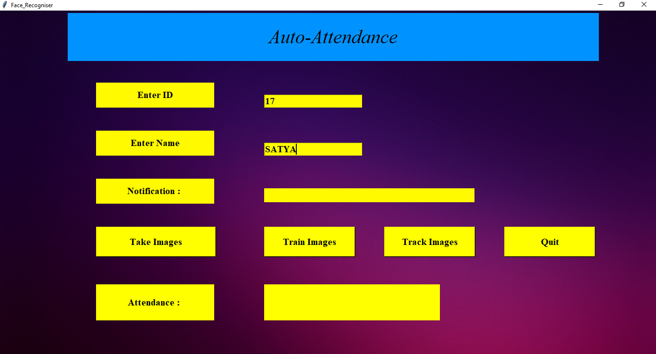

**CLICK HERE**

The above figure represents how to add student details/Take Images of the student.

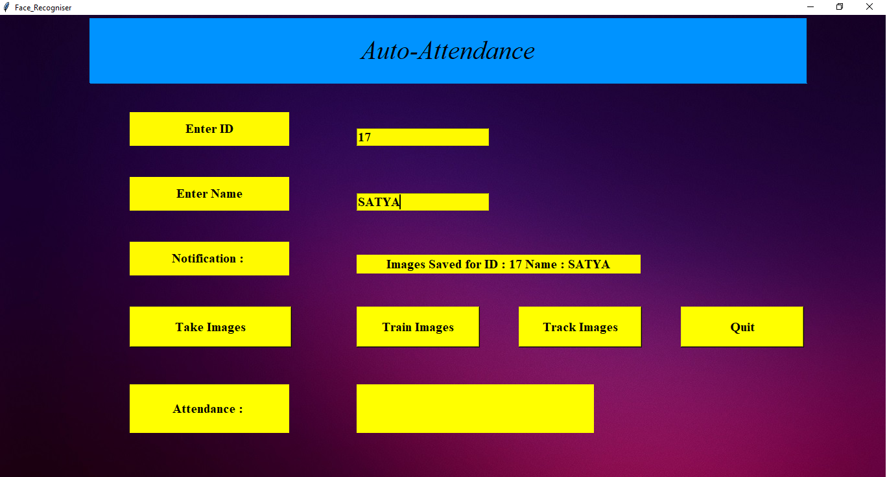

**CLICK HERE**

The above figure represents the student details are added. And Training Images is in progress.

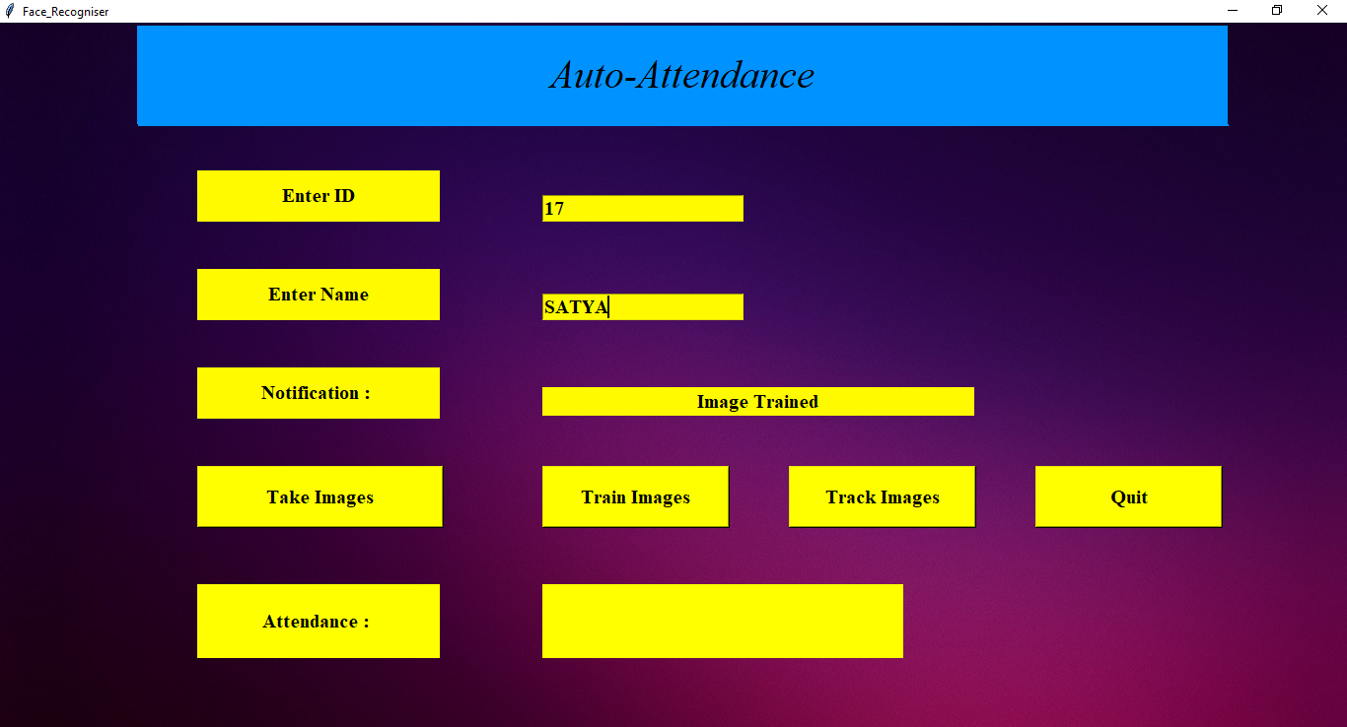

The above figure represents the system is trained.

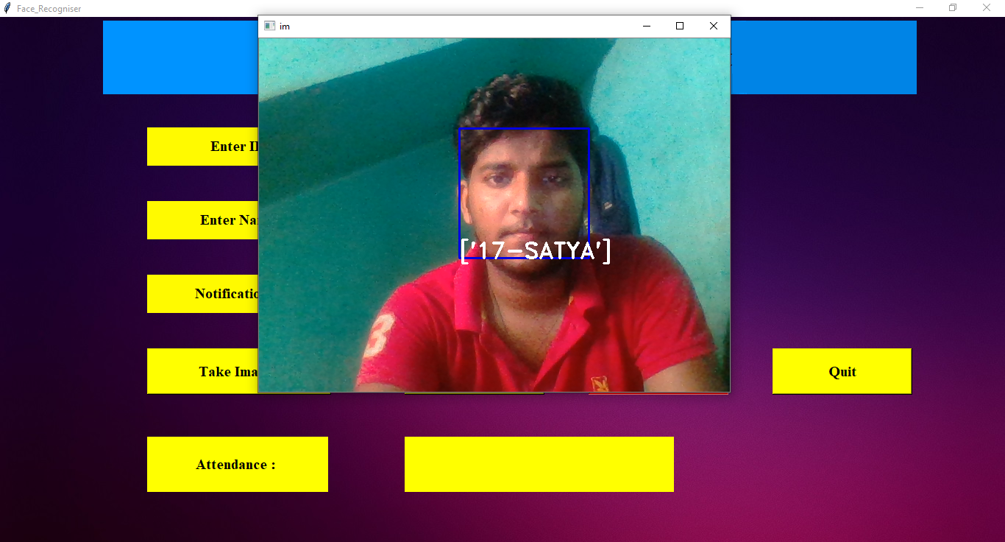

**CLICK HERE**

The above figure represents the face recognition.

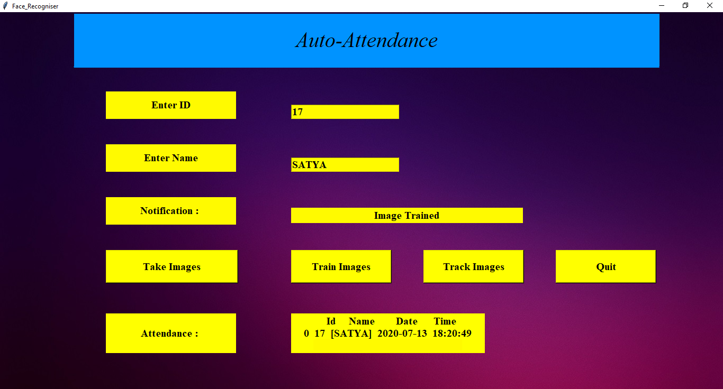

The above figure represents the attendance is marked.

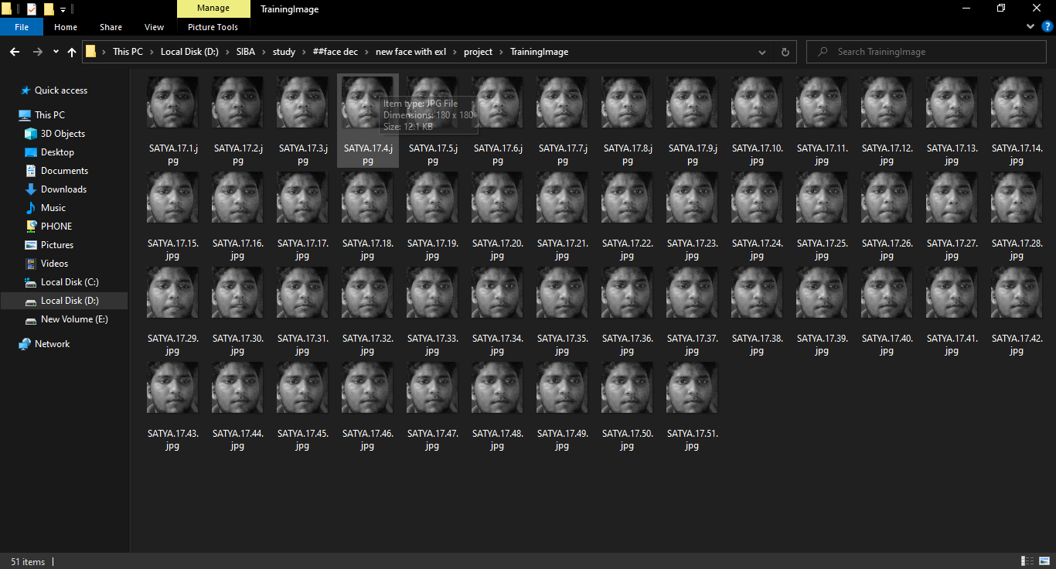

The above figure represents the images captured by the system.



The above figure represents the student record



The above figure represents the student attendance record

## CHAPTER – 10 FINDING AND CONCLUSION

The Automatic Attendance System using face recognition is a very effective tool which can be used to a great extent. The System is portable and can be easily access and used on any computer. Using this software, proxies are completely avoided with a pure software approach. It will reduce the time, effort and resources such as paper for both the parties involved in the process. Moreover, it will eliminate the tedious work of the teachers for maintaining different attendance sheet for different classes and different subjects.